Design Pattern 1 - Template Pattern

This pattern is based on the existence of a superclass and several subclasses extended from that superclass. This pattern is used when there are several similar objects do the same things but in a different way, e.g. abstract class with one or more abstract methods that are implemented in the respective subclasses each in a different way.

This pattern saves a few lines of code and provides an understandable code without repeated methods.

Code Snippet

public class SpaghettiMeatballs extends PastaDish {

public void addPasta() {

System.out.println("Add spaghetti");

}

public void addProtein() {

System.out.println("Add meatballs");

}

public void addSauce() {

System.out.println("Add tomato sauce");

}

public void addGarnish() {

System.out.println("Add Parmesan cheese");

}

}

public abstract class PastaDish {

final void makeRecipe() {

boilWater();

addPasta();

cookPasta();

drainAndPlate();

addSauce();

addProtein();

addGarnish();

}

abstract void addPasta();

abstract void addSauce();

abstract void addProtein();

abstract void addGarnish();

public class PenneAlfredo extends PastaDish {

public void addPasta() {

System.out.println("Add penne");

}

public void addProtein() {

System.out.println("Add chicken");

}

public void addSauce() {

System.out.println("Add Alfredo sauce");

}

public void addGarnish() {

System.out.println("Add parsley");

}

}

private void boilWater() {

System.out.println("Boiling water");

}

Structure

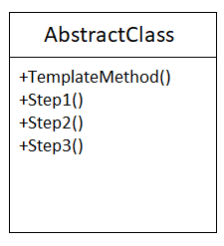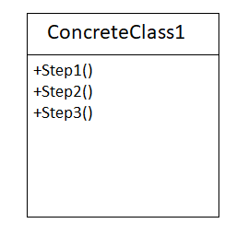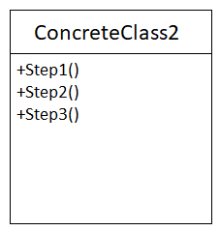

Code Location

The classes are in a package in the following path:

*“src/main/java/ org/jabref/logic/citationKeyPattern”*

The abstract superclass is call AbstractCitationKeyPattern and have one abstract method call getLastLevelCitationKeyPattern(EntryType key). This method is implemented in several subclasses named: DatabaseCitationKeyPattern and GlobalCitationKeyPattern.

In GlobalCitationKeyPattern subclass:

public class GlobalCitationKeyPattern extends AbstractCitationKeyPattern{…}

@Override

public List<String> getLastLevelCitationKeyPattern(EntryType entryType) {

return defaultPattern;

}

In DatabaseCitationKeyPattern subclass:

public class DatabaseCitationKeyPattern extends AbstractCitationKeyPattern{…}

@Override

public List<String> getLastLevelCitationKeyPattern(EntryType entryType) {

return globalCitationKeyPattern.getValue(entryType);

}

In AbstractCitationKeyPattern superclass:

public abstract List<String> getLastLevelCitationKeyPattern(EntryType key);